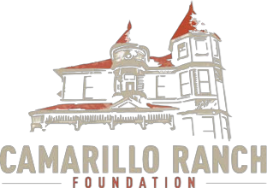
School Tour Reservation Form School Tours are presented on Wednesdays from 9:30am – 11:45am during the school year.
Today’s Date: _____________
Name of School: ________________________________________________________________________ Address:_______________________________________________________________________________ Main Contact:___________________________________________________________________________ Phone (school): ________________________________ (other):___________________________________ Email(s):_______________________________________________________________________________ Requested Date(s)-Please give a 1st & 2nd choice(s): ______________________________________________________________________________________
Grade: _______ # of students (60 maximum): ____________
To better accommodate your students on the day of their tour, please specify if there are any with Special Needs, and/or any from a Special Education Class:____________________________________________ _____________________________________________________________________________________
Please note: Name tags are required – Docents will place students into small groups upon arrival. We are following County of Ventura and School District restrictions regarding COVID-19.
Teachers Attending Tour:___________________________________________________________________
Number of Chaperones: ____________ Note: Due to limited space inside the Victorian Mansion, please limit chaperones to two (2) per eight (8) students. Students who require adult helpers due to special needs will be the only exception.

Transportation: Bus ____Carpool____ Will you enjoy a packed lunch in the gardens? Yes ____No_______ Time:_______
Other:___________________________________________________________________________________

Please mail, or email, this form to: Camarillo Ranch
201 Camarillo Ranch Road, Camarillo, CA 93012
P: 805.389.8182 | F: 805.389.8183 | E: info@camarilloranch.org
www.camarilloranchfoundation.org

