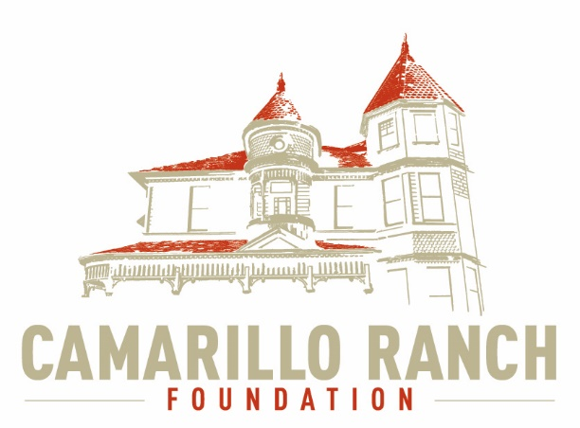 Camarillo Ranch Foundation, Inc.
Board of Directors Agenda
July 7, 2021 – 5:30 PM
Camarillo Ranch – Zoom Meeting
201 Camarillo Ranch Road
Camarillo, CA 93012

284th Meeting
“Preservation, Education, Restoration”

- Call to Order – David Schlangen
- Action to approve minutes of meeting held on June 2, 2021
- Next Meeting – August 4, 2021
- Public Comments/Board Comments:
  - Pubic comments regarding items not on the agenda
Docent Representative
  - Board/City comments
- Unfinished Business:
- New Business:
  - Appoint Interim Secretary for tonight’s meeting
  - Swear in new Board Members (Review updated Board Directory)
  - Officer Elections
    - President
    - Vice-President
    - Treasury
    - Secretary
  - Review Approved Photo Pass Application and Filming Feedback
    - Reminder for Board Members to be available for upcoming Photo Pass dates
    - Additional Lessons Learned from Filming
    - Update on Location Manager/Scout for Ranch Property Filming
  - Action on whether to have a Virtual or a Video tour of Ranch House
  - Action to approve Budget for Education and Legacy Committee
  - Committee Reports
    - Executive/Finance Committee
    - Education and Legacy Committee
    - Social Media Task Force
    - Fund Development/Event Committee
- Closed Session – Discussion on Website
- Adjournments – David Schlangen

Future Topics:
City/Command Performance/CRF Calendar

_______________________________Sheryl Gonzalez
CRF Board Agenda July 7, 2021

Distribution:
Camarillo Ranch Foundation Board Members
City Clerk, City of Camarillo

Staff reports and other disclosable public records related to open session agenda items are available for review at the Camarillo Ranch Office located at 201 Camarillo Ranch Road, Camarillo, CA 93012. If you have any questions, please contact the Ranch Office at (805) 389-8182.

Americans with Disabilities Act Compliance Statement
In compliance with the Americans with Disabilities Act, if you need special assistance to participate in this meeting, please contact the Camarillo Ranch Office at (805) 389-8182 at least 48 hours prior to the meeting to enable us to make reasonable accommodations to ensure access to this meeting. (28 CFR 35.102-35.104, ADA Title III)

