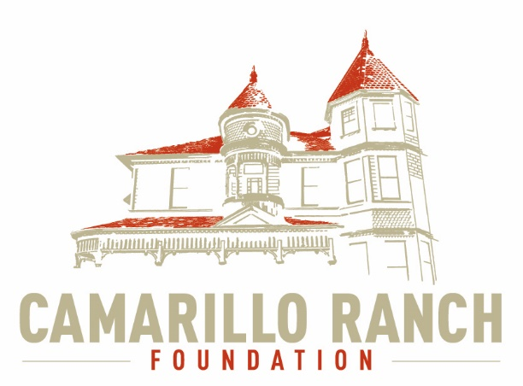 Camarillo Ranch Foundation
Board of Directors Meeting Minutes
June 2, 2021 – 5:30 pm
Camarillo Ranch – Zoom Meeting
201 Camarillo Ranch Road
Camarillo, CA. 93012

283rd Meeting
“Preservation, Education, Restoration”

- Call to Order – David Schlangen called the meeting to order at 5:31 PM. Present: Ana Blattel, Betty Addieg, Christopher Valenzuela, David Schlangen, Helen Faul, Kathy Taylor, Matt Kohagen, Mike Morgan, Sheryl Gonzalez, Theresa Marvel Absent: Mary Goldberg
- Minutes – Minutes of meeting held May 5, 2021,were unanimously approved with corrections.
- Next Meeting – July 7, 2021
- Public Comments/Board Comments:
  - Public Comments regarding items not on the agenda
  - CRF Board/City Comments
    - This evening on the TV channel, KEYT, Molly from Command Performance was interviewed about the opening of the Ranch for Weddings and other events.
    - Molly has prepared a calendar from Command Performance of upcoming events.
    - Theresa Marvel thanked David Schlangen for all his hard work especially the time he spent at the Ranch during the last filming event. Kathy Taylor, Mike Morgan, Chris Valenzuela, Helen Faul, Theresa Marvel, and Ana Blattel also helped David during the filming event.
    - David Schlangen reported:
      - The annual RRF document has been sent to the Secretary of State of California.
      - There has been some fraudulent activity on the CRF Website. Higher security has been added to the Website. The part of the Website that was compromised has been temporarily closed down.
      - There are new signs on the property, stating the hours of operation, rules for photography, and times for House Tours.
      - Some Bloggers (Run the Atlas) contacted ‘Visit Camarillo’ and expressed an interest in visiting the Ranch House. David and Sheryl Gonzalez met with them at the House and took them on a Tour. David will inform the Board when their Blog is up.
      - There was an article in The Acorn about the filming at the Ranch.
      - At the next meeting there will be nominations for the new Board Executive Committee Members for July 2021 to July 2022.
- Unfinished Business: None
- New business:
  - Discussion/Action on Commercial Still Photography and Filming application
    - Lessons learned and best practice from concluded filming
      - There was a lengthy discussion on what went well and what needs to improve. Everyone who helped out during the filming was asked to submit to David a list of what went well and what needs to be improved. Theresa Marvel has already submitted her list.
      - It was agreed by everyone that a contract needs to be developed that would be legally binding. This contract must be very specific as to what the filming crew can and cannot do and include all charges for extra items.
    - Payment breakdown discussion
      - Matt and Theresa have made contact with other organizations about how much they charge and what they include in their contracts.
      - The original costs for filming at the Ranch were high. Some of the days were a lot longer then 8 hours. Adjustments need to be made for daily length of filming.
    - Harbor Freight has expressed an interest in using the House as a background for advertising.
    - A photo pass is being revised for photographers to take photos on the grounds. This pass will be for two-hour increments of $55. All photo shoots must be on the days Molly is at the House. A CRF representative must accompany photographers. Photographers must leave the grounds exactly as they found them.
  - Action on new Board members
    - There are four new applicants to the Board.
    - The Nominations Committee recommended all four applicants, Shelby Paul, Peg Hicks-Moore, Eric Storrie, and Vishnu K. Patel.
    - Theresa Marvel made a motion to accept all 4 applicants. Ana Blattel seconded the motion. The Action was unanimously approved. The new members will be asked to attend the next Board meeting.
  - Action on badges for Current/New Board members
    - Motion was made by Mike Morgan to get Badges for all Board members. Chris seconded the motion. The Action was unanimously passed.
    - David will contact companies to get cost estimates.
  - Action on either Virtual/Video/Website Tour of Ranch House (If Meadowlark Service League grant captured)
This Action was tabled until the July 7 meeting. At this time the CRF Board should know if the Meadowlark Service League awarded the CRF a grant to pay for the cost of the Virtual/Video.
  - Creation of Event Committee and assigning members
This committee would plan and coordinate all events. It would work directly with the Fund Development committee. David and Mary Goldberg volunteered to be on this committee.
  - Update on Grant Fund opportunities
Mike Morgan sent a list to David.
  - Action to approve the purchase of School Tour Booklets
Sheryl Gonzalez made a motion to approve the purchase of the School Tour Booklets. Mike Morgan seconded the motion. The Action was unanimously approved.
  - Action for unanimous approval to begin having in-person Board meetings in September 2021.
Helen Faul made a motion to approve the action to begin in-person meetings in September. Kathy Taylor seconded the motion. The Action was unanimously approved.
  - Action on Office Printer
    - Theresa Marvel presented a cost analysis of three different companies. Coastal Copy of Oxnard offered the CRF the best price.
    - Helen Faul made a motion to have Coastal Copier provide the contract for the new printer. Ana Blattel seconded the motion. The Action was unanimously approved.
  - Committee Reports
- Executive/Finance Committee
  - The Executive created the agenda for the Board meeting.
  - CRF finances for April
    - Net income $16,000
    - $150,000 in assets, includes Edward Jones account
    - $48,000 in checking account.
- Education and Legacy Committee
  - Docent Meeting
    - House Tours will begin in September and will be on
Saturdays and Sundays.
    - School Tours will begin in October on Wednesdays.
    - The Christmas bins were put into the storage unit. The Docents will decorate the inside of the House for Christmas.
    - A budget is being developed for the Docents.
    - The Procedures Committee will be meeting June 3 to begin work on updating the Volunteer/Docent procedures.
  - Ana and David met with a person from the City to help find a volunteer to work in the office when Docents are at the Ranch. This volunteer will answer phones and perform various secretarial duties.
- Social Media Task force
  - Bev Miller has been very helpful with sending articles for the Website.
  - There was an article in the Acorn that was very favorable to the Ranch.
  - The CRF Facebook page is more popular with woman.
  - Anyone who has photos please send them to Chris Valenzuela.
  - The CRF is set up on Amazon Smile.
- Fund Development Committee
  - The committee is still waiting to hear when the Camarillo Ranch House will open.
- Nomination Task Force
The Task Force has completed its task.
- Closed Session - Additional Web Designer payment and Christmas moving payment.
  - The Board adjourned to closed session at 8:34 PM and returned to open session at 8:41 PM.
  - Action to pay Web Designer an additional $50 was approved and Action to pay Carlos Solis $250 for moving Christmas Bins to Storage Unit was approved.

- Adjournment – David Schlangen adjourned the meeting at 8:44 PM.

Future Topics:
City/Command Performance/CRF Calendar

CRF Subcommittee Meetings – The Foundations subcommittees meet monthly or as indicated below. All meetings are currently held virtually.

Docent Executive Committee First Monday 9:00 AM
Executive/Finance Committee Third Tuesday 5:30 PM
Social Media Task Force Second Thursday 5:00 PM
Education and Legacy Committee Second Tuesday 10:00 AM
Fund Development/Event Committee No date at this time

_________________________________________Sheryl Gonzalez
CRF Board Minutes June 2, 21

Distribution:
Camarillo Ranch Foundation Board Members
City Clerk, City of Camarillo

Staff reports and other disclosable public records related to open session agenda items are available for review during regular business hours, Monday-Friday, 8:00 a.m. to 5:00 p.m., at the Camarillo Ranch Office located at 201 Camarillo Ranch Road, Camarillo, CA 93012. If you have any questions, please contact the Ranch Office at (805) 389-8182

Americans with Disabilities Act Compliance Statement
In compliance with the Americans with Disabilities Act, if you need special assistance to participate in this meeting, please contact the Camarillo Ranch Office at (805) 389-8182 at least 48 hours prior to the meeting to enable us to make reasonable accommodations to ensure access to this meeting. (28 CFR 35.102-35.104, ADA Title III)

