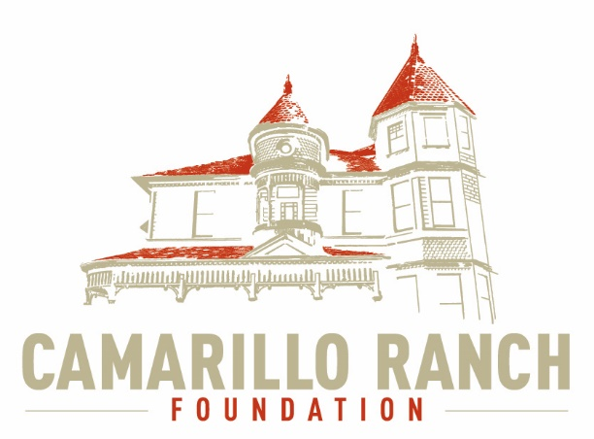 Camarillo Ranch Foundation
Board of Directors Meeting Minutes
May 5, 2021 – 5:30 PM
Camarillo Ranch – Zoom Meeting
201 Camarillo Ranch Road
Camarillo, CA. 93012

282th Meeting
“Preservation, Education, Restoration”

- Call to Order – David Schlangen called the meeting to order at 5:31 PM.
Present: Betty Addieg, Christopher Valenzuela, David Schlangen, Helen Faul, Kathy Taylor, Mary Goldberg, Matt Kohagen, Mike Morgan, Theresa Marvel, Sheryl Gonzalez and Ana Blattel
- Minutes – Minutes of meeting held on April 7, 2021 were unanimously approved with two corrections.
- Next Meeting – June 2, 2021
- Public Comments/Board Comments:
  - Public Comments regarding items not on the agenda
    - No public comments
    - No Docent Representative comments
  - Board/City Council Member Comments:
    - Mike Morgan reported that there would be a meeting with the City at the Library on May 19th at 5:00 to discuss the City’s budget for upcoming community events.
    - David Schlangen and Ana Blattel have been working with a filming company that is developing a movie, to be filmed at the Ranch House for the Hallmark Channel. The company will be filming from May 13 to May 17. David asked Board members to send him an email if they could help out during filming. Kathy Taylor, David, Mike Morgan, Chris Valenzuela, and Theresa Marvel have volunteered to be at the House. David will develop a schedule. Carmen Nicholas is developing a contract the Board may use. David will reach out to Marty Daily and Gerry Olsen about past film contracts.
    - Harbor Freight is interested in using the House in a photo shoot.
    - NBC Universal is also interested in using the House for a possible commercial.
    - Any Commercial Still Photography and Filming companies on site must first contact the City for all necessary permits. They must also provide insurance.
- Unfinished Business – N/A
- New business–
  - Updates/Changes to the CRF Website
    - The School Tour Video was added to the Website.
    - A video of Adolfo Camarillo was added.
    - There is now a map, provided by the Master Gardeners, of the Gardens.
    - Other historical articles have been added. Martina Nicholson, Adolfo’s great granddaughter, donated money to help produce these articles. The Family is very excited about the articles. The Social Media Task Force has been working very closely with a Web Designer to help update our Website.
  - Action on either Virtual/Video/Website tour of Ranch House
This action was tabled until the CRF Board hears back from the Meadowlark Service League about the status of our Grant application.
  - Discussion/Action to update Photography and Filming Costs
The CRF Board needs to review the current application and costs to create a new application and contract.
      - Security fees need to be updated. Does the company have their own security or does the CRF need to provide security?
      - How much the CRF Board charges per day. What would the hourly costs be? What are the differences between costs for Still Photography vs. Filming?
      - Something to discuss later, could be offering different pricing for local businesses.
      - Links with the City for permits and insurance information must be included.
      - Matt Kohagen and Theresa Marvel will research other venues for Fair Market value.
  - Update on Grant Funding Opportunities
    - Mike Morgan is complying a list and will send it to David. He stated that most Banks have a foundation. David will send this list to the Grant Writer. She will review list and let the CRF know if the companies listed have a good track record.
    - Matt will research how to get the Ranch House on the approved “Smile List” at Amazon.
    - When applying for any Grants the CRF Board needs to emphasize the School Tours and the Bus Grants the CRF provides.
  - Committee Reports
    - Executive/Finance Committee
      - The Executive Committee met to create the Board Agenda.
      - Helen Faul reported on the finances.
        - Income for month of April - $2,010.50
        - Expenses - $1,204.13
        - Assets - $147,971.81 (including the Edward Jones account)
        - There is money in the budget to pay for the School Tour Student booklets.
    - Education and Legacy Committee:
      - Accessions of any objects for the House will be put on hold until after the House is fully opened.
      - Ana Blattel updated what is happening with the Docents:
        - The Docents will be meeting in June to begin revising the Docents Procedures and Bylaws.
        - She has been talking to Carmen at the City of the possibility of getting someone to help out in the office when the Docents are present. This would be a voluntary position.
        - In the past the Docents came up with ideas for events, for example Adolfo Camarillo’s birthday party and the Santa Nights. The Docents would ask the office for help. Since there is no one in the office there is now a necessity for the CRF Board to create an Events Committee. David and the CRF Board agreed. This committee will be formed in the future when the new Board members come onboard.
    - Social Media Task force – Chris Valenzuela and Mary Goldberg
      - Chris shared what has been posted on Facebook and Instagram. The Task Force is working on making information posted more educational and relevant. Our viewer numbers are going up.
      - Mary stated that the Volunteer Roster has been updated.
    - Fund Development Committee
Everything is on hold until it is known when the Ranch House may re-open.
    - Nomination Task Force – Helen Faul, Matt Kohagen, Kathy Taylor
      - All the timelines are being met.
      - The committee has approved all four applicants.
      - The applicants are a very diverse group with varying skills.
      - The next step is for the whole CRF Board to review the applicants’ résumés and vote.
      - Joe Ortiz sent the committee a thank you note, thanking the committee for including him in the evaluation process.
- Closed Session – Discussion on Ranch Foundation/ Website Designer Payment. The Board adjourned to close session at 7:29 PM and returned to open session at 7:34 PM.
- Adjournment – David Schlangen adjourned the meeting at 7:36 PM.

Future Topics
City/Command Performance/CRF Calendar

CRF Subcommittee Meetings – The Foundations subcommittees meet monthly or as indicated below. All meetings are currently held virtually.

Docent Executive Committee First Monday 9:00 AM
Executive/Finance Committee Third Tuesday 5:30 PM
Social Media Task Force Second Thursday 5:00 PM
Education and Legacy Committee Second Tuesday 10:00 AM
Fund Development Committee No date at this time

_________________________________________Sheryl Gonzalez
CRF Board Minutes May 5.21(5.24.21)

Distribution:
Camarillo Ranch Foundation Board Members
City Clerk, City of Camarillo

Staff reports and other disclosable public records related to open session agenda items are available for review during regular business hours, Monday-Friday, 8:00 a.m. to 5:00 p.m., at the Camarillo Ranch Office located at 201 Camarillo Ranch Road, Camarillo, CA 93012. If you have any questions, please contact the Ranch Office at (805) 389-8182.

Americans with Disabilities Act Compliance Statement
In compliance with the Americans with Disabilities Act, if you need special assistance to participate in this meeting, please contact the Camarillo Ranch Office at (805) 389-8182 at least 48 hours prior to the meeting to enable us to make reasonable accommodations to ensure access to this meeting. (28 CFR 35.102-35.104, ADA Title III)

