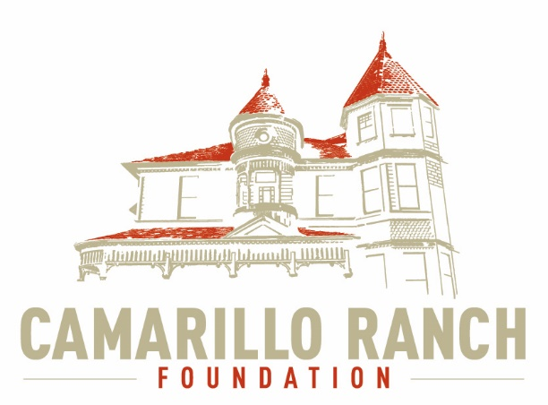 Camarillo Ranch Foundation
Board of Directors Meeting Minutes
September 2, 2020 – 5:30 pm Camarillo Ranch – Zoom Meeting
201 Camarillo Ranch Road
Camarillo CA. 93012

275th Meeting

“Preservation, Education, Restoration”

- Call to Order – David Schlangen called the meeting to order at 5:31.
Present – Ana Blattel (Vice Pres.) Christopher Valenzuela, David Schlangen (Pres.) Helen Faul (Treas.) Kathy Taylor, Mary Goldberg, Matt Kohagen, Sheryl Gonzalez (Sec.) Theresa Marvel
Absent – Mike Morgan, Betty Addieg
- Minutes – The minutes from the August 5, 2020 meeting were unanimously approved.
- Next Meeting – October 7, 2020
- Public Comments/Board Comments:
  - Public Comments regarding items not on the agenda.
    - There were no comments.
    - There were no Docent Representative comments.
  - Board President – David Schlangen
    - David still not sure when we will be allowed to meet in the house. The next meeting will be on Zoom.
    - Ana Blattel (Vice President) is now one of three signers on the CRF account.
    - Sparkletts Water contract has been cancelled.
    - David is working with the city to update the CRF information for VCFC (Ventura County Film Commission for Small Business) in case they would like to film at the Ranch. The CRF bylaws, which will be updated, state the parameters any film company must follow when filming at the Ranch. Any revenue received from filming goes directly to the CRF.
    - A report to the city about events from November 2019 must be presented to the city. The only events held since then were Santa Nights in December 2019.
    - David displayed the CRF Process Flow Diagram and explained the process. All ideas/suggestions must first go to the correct committee. That committee will make recommendations to the Executive Committee and the Executive Committee will decide whether or not to send the recommendations to the CRF Board for voting. It is important that all board members are included in any decisions.Theresa Marvel asked a question about the Docents and how their committee fit into the Flow Diagram. Ana Blattel responded that the Docents are under the Education and Literacy Committee and a future Flow Diagram is being developed for their group.
  - Board Comments
Theresa Marvel asked David Schlangen if he had spoken to Carmen Nichols (City Rep.) about the audit payment. David replied that he had emailed Carmen and was still waiting for a response.

- Unfinished Business:
Committee Dates and Times
Fund Development – The committee still needs to talk to Karen King about Green Light before setting up a meeting time. David will check in the office to see if there is a password for Green Light.
- New Business:
  - Task force to update Board Agreement, Policy and Procedure. Documents.
    - Gerry Olsen will assist with the update of these documents.
    - Ana Blattel, Helen Faul and Sheryl Gonzalez volunteered to help Gerry.
  - Action was taken to not hold CRF events for the rest of 2020.Helen Faul made the motion and Mary Goldberg seconded. The action was passed with an eight to one vote. Most members felt the need to wait to plan any events until the city allows theRanch to open to the public.
  - Action was taken to use Camarillo companies to create “Ceremonial Bricks”.Sheryl Gonzalez made the motion to approve the action and Kathy Taylor seconded. The action was unanimously approved.
  - Action to nominate Yolanda Salvas to the CRF Board of Directors. David Schlangen shared the CRF Board bylaws (section 10 b) for filling vacancies, which states “vacancies on the Board shall be filled by a majority vote of the Board”. Helen Faul made the motion to nominate Yolanda Salvas to the Board and Theresa Marvel seconded the motion. The action was unanimously approved to nominate Yolanda to the CRF Board. David will speak to Yolanda about accepting the placement.
- Reports:
  - Executive Committee - David Schlangen (president)
The Executive Committee comes up with the agenda for the board meetings. Any items the board members wish to add to the agenda must be sent to the Executive Committee first.
  - Finance – Helen Faul (secretary) reviewed the CRF Profit/Loss forms from August 1 – August 24.
    - Presently we are losing money. Since the Ranch is closed we have no way to make money. We need to reach out to past donors.
    - A question was asked concerning the cost of the copy machines. CRF splits the cost with Command Performance. CRF pays the total cost and Command Performance reimburses the Foundation.
    - Yolanda Salvas is in the process of investigating and updating the CRF finances.
- Closed Session – The Executive Board met in closed Session. A motion was presented by Matt Kohagen to award Yolanda Salvas compensation for her help with the CRF finances from mid-July to September1, 2020. Kathy Taylor seconded the motion and it was unanimously approved.
- Adjournment – David Schlangenadjourned the meeting at6:43.

CRF Subcommittee meetings – The Foundation’s subcommittees meet monthly or as indicated below. All meetings are currently held virtually.

Docents Executive Committee First Monday 9:00 am
Executive/Finance Committee Third Tuesday 5:30 pm
Education and Legacy Second Tuesday 10:00 am
Social Media Task Force Second Tuesday 5:00 pm
Fund Development

______________________________________________________Sheryl Gonzalez
CRF meeting minutes September 2, 2020 (Sept. 12, 2020)

