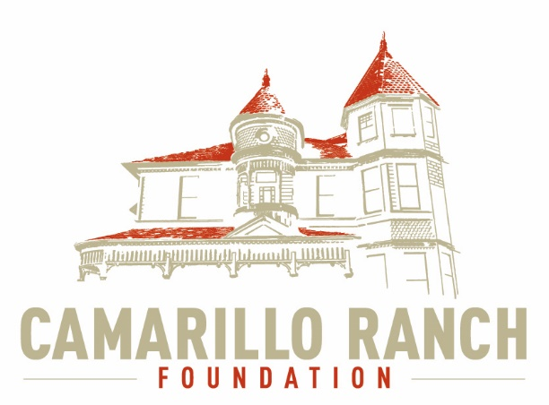

Camarillo Ranch Foundation Minutes - Board of Directors Meeting July 1, 2020 – 5:30 PM Camarillo Ranch – Zoom Meeting 201 Camarillo Ranch Road Camarillo, CA 93012

Meeting called to Order: 5:30 PM
Attendees: Betty Addieg, Kathy Taylor, Ana Blattel, Karen King, David Schlangen, Gerry Olsen, Matt Kohagen, Chris Valenzuela, Theresa Marvel, Sheryl Gonzalez, Mary Goldberg, Martin Daly, Ellen Smith, Carmen Nicholas, Helen Faul
Not Attending: Mike Morgan
Oath of Office to new Board Members administered by Gerry Olsen:
President – David Schlangen
Vice President – Ana Blattel
Secretary – Betty Addieg
Treasurer – Helen Faul
All new nominees were approved
Karen King and David Schlangen thanked all the out-going Board members for their service and dedication to the Board.
1) Approval of June 3, 2020 Minutes
2) Comments: Any City or public person may speak at this meeting for 3 minutes during this time.
Carmen Nicholas congratulated the new Board members.
Updates: The business office at the Ranch will be opening July 8 on a limited basis from 9 AM to 5 PM, Wednesday thru Sunday. There can be no weddings or gatherings at the Ranch at this time. It does allow for some wedding ceremonies with restrictions.
3) Board President: working on the Directors & Officers policy and a commercial policy. Asking for three quotes to get the best price.
Working with a new accountant Yolanda Salvas.
Amgen Foundation won’t be able to extend financial assistance to the Ranch at this time.
The computer server at the Ranch went down, is now back up, working with Sandy Nirenberg.
Have obtained the saddles from Mary Feester. Will need longer cords to wrap around the saddles for better security.
4) Board comments:
Ana mentioned that a number of things voted on by the previous Board might need to be reviewed by this new Board and voted upon.
Sheryl said the Orientation packet and policies should be updated since the previous Board approved them. Will want to use an updated version for this Board.
Helen wanted to know how the Brown Act applies to the Board. Gerry Olsen is working with the City Clerk. Hoping to get her to come to a meeting to update us.
5) New Business:
The time and date of the Board business meeting is the 1st Wednesday of each month at 5:30 PM (after work hours). Next meeting in August is through ZOOM.
Officer Signature Authorization - checks sent out for payment must always have two signatures, President and Treasurer, on the check. Motion was carried.
Thank you to Gerry and Joan Olsen for the new flag pole, in memory of their daughter, on the Ranch grounds.
Consideration: Little Green Light – maintain database, reach out to donors.
Consideration: Quick Books – Yolanda will be assisting with this. David and Marty Daly will be meeting with her.
Consideration of keeping up the website. David would like to create a task force to consolidate our Twitter, etc., to combine all our social media. Chris Valenzuela has agreed to head this task force.
Chamber of Commerce membership is $300 annually. Mary Goldberg would be our liaison to the Chamber. It was discussed that we postpone our membership at this time and look into joining at some later date. Motion carried
6) Reports:
Executive Committee will meet the 3rd Tuesday of each month at 5:30 PM. Meeting will be on July 21st.
Board Development Committee – Board can take on this committee.
No discussions from new Board
Meeting adjourned at 6:49 PM

