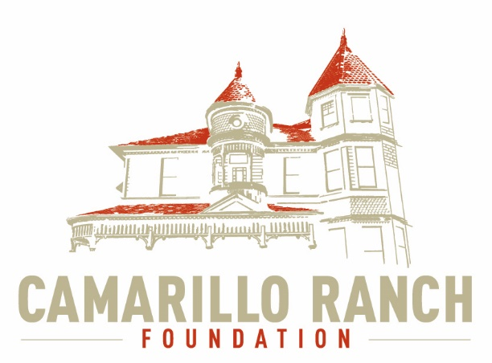 Camarillo Ranch Foundation
Board of Directors Meeting Minutes
April 7, 2021 – 5:30 PM
Camarillo Ranch – Zoom Meeting
201 Camarillo Ranch Road
Camarillo, CA. 93012

281th Meeting
“Preservation, Education, Restoration”

- Call to Order – David Schlangen called the meeting to order at 5:31 PM.
Present: Betty Addieg, Christopher Valenzuela, David Schlangen, Helen Faul, Kathy Taylor, Mary Goldberg, Matt Kohagen, Mike Morgan, Theresa Marvel, and Sheryl Gonzalez.
Absent: Ana Blattel
Guests: Lynette Coverly and Martin Daily
- Minutes –Minutes of meeting held March 3, 2021 were unanimously approved.
- Next Meeting – May 5, 2021
- Public Comments/Board Comments:
  - Public Comments regarding items not on the agenda
    - No public comments
    - No Docent Representative comments
  - Board/City Council Member Comments:
    - Mike Morgan asked if the CRF knew when the City would open up the Ranch House. David Schlangen stated that Carmen needs a plan and that Ana Blattel, the Docent Chairperson, is working on one with the Docents. David hopes to get direction from the City at the next City Council meeting. A question was asked about the possibility of inviting the Mayor to our next meeting. David will contact the Mayor’s office to see if that is possible. Mary Goldberg asked when the House was getting painting. David will look into when and get the information back to the CRF Board members.
    - David Schlangen reported:
In June our insurance will be due. David and Matt Kohagen are looking into ways to lower costs.
- Unfinished Business – N/A
- New business–
  - Introduction of Lynette Coverly (Event Planner)
    - Lynette Coverly discussed what her company could do for the Ranch to help with fund raising.
    - Her company is a full service Marketing Service with a three-tier program.
      - Brand Development
      - Market Out Reach Plan
      - Turnkey Implementation
    - She began her presentation with discussing the various associations she has worked with and what she did for them.
    - Her company has a flat fee.
      - For Virtual Events the initial cost is $5,000.
      - For In Person Events the initial coast is $10,000.
    - After the presentation the CRF Board discussed the possibility of hiring Lynette’s company. It was felt that her company was too expensive for the CRF fund raising events.
  - Continue Brainstorming session on possible events for 2021 at Ranch property and begin prioritizing them. Then action to approve list. The Fund Development Committee reported:
    - Mike Morgan talked to the Carnival owner and he is on board to set up Carnival rides whenever the CRF needs them. The CRF would get 25% of whatever he makes. The Carnival could be a stand along event or in connection with another event.
    - The first events the CRF organizes need to be outside and to let the community know the Ranch House is open.
    - Action was taken to approve the list of events. Matt Kohagen made a motion to approve the list and Mike Morgan seconded the motion. The motion was unanimously approved.
      - Movie Night(s)
      - Concerts on the Front Lawn
      - Chili Cook-Off
      - Car Show (in connection with the Fiesta)
  - Committee Reports
    - Executive/Finance Committee
      - Helen Faul, Treasurer, reported that right now the information the CRF has is a month behind. Tammy is still working on getting all the information updated. The total monthly operating costs are $1,685. The Assets are $148,267, which includes the Edward Jones account. Command Performance is still paying half of the costs for the printers. This will stop when June comes and the contract for the copy machines is up. Command Performance is not renewing their part of the contract. The CRF has decided to also not renew the contract. The CRF is hoping the City will provide the CRF with a used printer.
      - The Executive committee discussed:
        - The possibility of having to change the dates and times for House Tours when the Ranch re-opens.
        - David has applied to the Meadowlark association for a grant to pay for the Virtual/Video Tour. There are still concerns about the cost and type of tour the CRF wants.
    - Education and Legacy Committee:
      - The House inventory of the second floor was completed.
      - A pitchfork was found in a closet in the House. The committee needs to find out where it came from.
      - Mary Goldberg and Kathy Taylor have updated the Docent Roster and will be calling Docents to see who will be coming back to the Ranch.
      - The committee is looking at the possibility of hiring a company to create a Virtual Tour or Video of the Camarillo Ranch House for the Website.
        - The length of the Tour is a concern.
        - Would a Video Tour be better to have then a Virtual Tour?
        - The cost is an important factor.
        - Chris Valenzuela and Mary Goldberg have been doing an excellent job with the website.
    - Social Media Task force – Chris Valenzuela and Mary Goldberg
      - There are more photos on the Website and the articles are now on a link. If anyone has more photos and/or articles please forward to Chris Valenzuela. Beth Miller has been very helping in providing articles.
      - The committee is working towards adding the articles to the CRF Facebook page. Chris and Mary are focusing on Facebook and Instagram.
    - Fund Development Committee
Discussed under new business (b)Continue Brainstorming session on possible events for 2021…
    - Nomination Task Force – Helen Faul, Matt Kohagen, Kathy Taylor
      - Helen Faul called the Acorn about putting the information in the paper.
      - There are two applicants with the possibility of one more.
      - Applications are due by 5:00 PM on April 30, 2021.
- Closed Session – Discussion on Ranch Foundation/Command Performance Meeting. The Board adjourned to closed session at 7:21 PM and returned to open session at 7:51 PM.
- Adjournment – David Schlangen adjourned the meeting at 7:52 PM.

Future Topics
- City/Command Performance/CRF Calendar
- Action on either Virtual/Video/Website Tour of Ranch House.

CRF Subcommittee Meetings – The Foundations subcommittees meet monthly or as indicated below. All meetings are currently held virtually.

Docent Executive Committee First Monday 9:00 AM
Executive/Finance Committee Third Tuesday 5:30 PM
Social Media Task Force Second Thursday 5:00 PM
Education and Legacy Committee Second Tuesday 10:00 AM
Fund Development Committee No date at this time

_________________________________________Sheryl Gonzalez
CRF Board Minutes April 7, 2021(4.26.21)

Distribution:
Camarillo Ranch Foundation Board Members
City Clerk, City of Camarillo

Staff reports and other disclosable public records related to open session agenda items are available for review during regular business hours, Monday-Friday, 8:00 a.m. to 5:00 p.m., at the Camarillo Ranch Office located at 201 Camarillo Ranch Road, Camarillo, CA 93012. If you have any questions, please contact the Ranch Office at (805) 389-8182.

Americans with Disabilities Act Compliance Statement
In compliance with the Americans with Disabilities Act, if you need special assistance to participate in this meeting, please contact the Camarillo Ranch Office at (805) 389-8182 at least 48 hours prior to the meeting to enable us to make reasonable accommodations to ensure access to this meeting. (28 CFR 35.102-35.104, ADA Title III)

