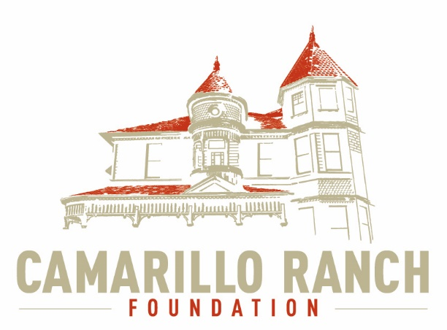 Camarillo Ranch Foundation
Board of Directors Meeting Agenda
April 7, 2021 – 5:30 PM
Camarillo Ranch – Zoom Meeting
201 Camarillo Ranch Road
Camarillo, CA. 93012

281st Meeting
“Preservation, Education, Restoration”

- Call to Order – David Schlangen
- Minutes – Action to approve minutes of meeting held on March 3, 2021
- Next Meeting – May 5, 2021
- Public Comments/Board Comments:
  - Public Comments regarding items not on the agenda
Docent Representative
  - Board/City Comments
- Unfinished Business –
- New business –
  - Introduction of Lynette Coverly (Event Planner).
  - Continue brainstorming session on possible events for 2021 at Ranch Property and prioritizing them. Then action to approve list.
  - Update on possible Grant Funding opportunities.
  - Committee Reports
- Executive/Finance Committee
- Education and Legacy Committee
- Social Media Task force
- Fund Development Committee
- Nomination Task Force
- Closed Session – Discussion on Ranch Foundation/Command Performance/City of Camarillo Meeting.
- Adjournment – David Schlangen

Future Topics:
- City/Command Performance/CRF Calendar
- Action on either Virtual/Video/Website Tour of Ranch House.

CRF Subcommittee Meetings – The Foundations subcommittees meet monthly or as indicated below. All meetings are currently held virtually.

Docent Executive Committee First Monday 9:00 AM
Executive/Finance Committee Third Tuesday 5:30 PM
Social Media Task Force Second Thursday 5:00 PM
Education and Legacy Committee Second Tuesday 10:00 AM
Fund Development Committee No date at this time

_________________________________________Sheryl Gonzalez
CRF Board Agenda April 7, 21

Distribution:
Camarillo Ranch Foundation Board Members
City Clerk, City of Camarillo

Staff reports and other disclosable public records related to open session agenda items are available for review during regular business hours, Monday-Friday, 8:00 a.m. to 5:00 p.m., at the Camarillo Ranch Office located at 201 Camarillo Ranch Road, Camarillo, CA 93012. If you have any questions, please contact the Ranch Office at (805) 389-8182.

Americans with Disabilities Act Compliance Statement
In compliance with the Americans with Disabilities Act, if you need special assistance to participate in this meeting, please contact the Camarillo Ranch Office at (805) 389-8182 at least 48 hours prior to the meeting to enable us to make reasonable accommodations to ensure access to this meeting. (28 CFR 35.102-35.104, ADA Title III)

