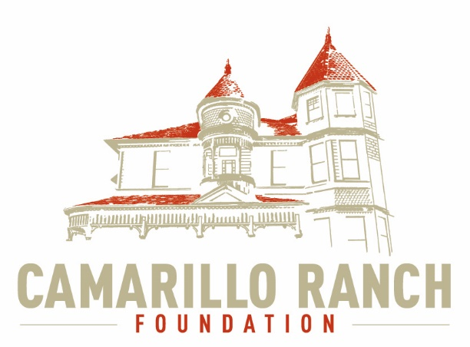 Camarillo Ranch Foundation
Board of Directors Meeting Minutes
March 3, 2021 – 5:30 PM
Camarillo Ranch – Zoom Meeting
201 Camarillo Ranch Road
Camarillo, CA. 93012

280th Meeting
“Preservation, Education, Restoration”

- Call to Order – David Schlangen called the meeting to order at 5:31 PM.
Present: Betty Addieg, Christopher Valenzuela, David Schlangen, Helen Faul, Kathy Taylor, Mary Goldberg, Matt Kohagen, Mike Morgan, Theresa Marvel, Ana Blattel and Sheryl Gonzalez.
- Minutes – Minutes of meeting held February 3, 2021 were unanimously approved.
- Next Meeting – April 7, 2021
- Public Comments/Board Comments:
  - Public Comments regarding items not on the agenda
    - No public comments
    - No Docent Representative comments
  - Board/City Council Member Comments
    - Theresa Marvel committed about an Article she saw in the Acorn. The Article stated that the City was allotting more money for the upkeep of the Camarillo Ranch House. Because of COVID the House has not been generating any revenue. She also stated if the City doesn’t maintain the House, the House will go back to the Camarillo Family.
    - Matt Kohagen asked, if the CRF knew when the House is scheduled to be painted. David stated it will take three to four weeks for the painting to be completed and that he will contact Public Works to find out when the painting will begin.
    - Matt also asked if the CRF could add information about the Ranch to the City Scope and on the Camarillo Local T.V. Channel.
    - David Schlangen reported:
      - The CRF accounts have been transitioned to QuickBooks on-line.
      - At our next meeting David will be inviting an Event Planner, Lynette Coverly to discuss her costs and ideas.
      - David has been researching various grant opportunities and grant writers. Mike Morgan and Theresa volunteered to help compile a list of Foundations in Ventura County that offer grants. Sandy Nirenberg submitted an application to the Meadowlark Association to help pay for a Virtual Tour of the Ranch House. In April or May the Meadowlark will let applicants know if they received a grant.
- Unfinished Business – N/A
- New business–
  - Continue Brainstorming session on possible events for 2021 at Ranch property and begin prioritizing them. The Fund Development Committee reported:
    - Matt Kohagen suggested that when the Ranch House is able to re-open the CRF should focus on outside activities first:
      - Movie Night(s)
      - Concerts on the Front Lawn
      - Chili Cook-Off
      - Car Show (in connection with the Fiesta)
    - The Chili Cook-Off could be connected with a Country Western Music night.
    - Food Trucks would still be considered in connection with the 4 recommended outdoor activities.
    - Mike Morgan called the carnival fellow about adding a carnival to the events. He said he would work with Mike about what he could do.
    - Casino Night is an activity the CRF could have in autumn, with the possibility of having the activity in a tent.
    - It was suggested to try tying activities with other non-profits such as The Lion’s Club.
    - Theresa Marvel suggested offering some type of car parades on the Ranch House grounds for special events, such as anniversaries, birthdays, graduations.
    - Ana Blattel reminded everyone all activities need to be coordinated with Command Performance, especially if the event needs the use of the barn.
    - The City will be following the County’s guidelines as to when the Ranch may open up. David will talk to Carmen about the City’s plan.
  - Committee Reports
- Executive /Finance Committee
  - The Executive Committee will discuss their upcoming Board Agenda at the next meeting on March 16.
  - Helen Faul reported that since the accounts are in transition to be on QuickBooks on–line there was nothing to report about the finances.
- Education and Legacy Committee
The committee has been looking at the possibility of hiring a company to create a Virtual Tour of the Camarillo Ranch House to put on the Website.
    - Sheryl Gonzalez spoke to Troy Wagner about a Virtual Tour. The cost would be anywhere from $450 to $2300 depending on what was included in the Virtual tour.
    - Theresa Marvel has talked to another company with similar costs. She said to make sure whatever company we use has a drone license.
    - The Social Media Task Force will talk to Pi-Design about what they may have to offer.
    - The Committee is still discussing the direction the CRF should go.
      - The length of the Tour is a concern. Do we just want a teaser to get people excited about visiting the House?
      - Would a Video Tour be better to have then a Virtual Tour? The Social Media Task Force has found some videos of the House on other websites.
- Social Media Task force – Chris Valenzuela and Mary Goldberg
  - There are now 3,581 followers on the Camarillo Ranch House Facebook page. If any Board member has anything they would like to share on Facebook please send it to the Task Force. They can post things from the Nomination Committee, the date when the painting of the House begins, any CRF events, photos of the gardeners, anything you can think up to get people’s interest.
  - The Instagram account has 2,121 followers.
- Fund Development Committee
Discussed under new business (a) Continue Brainstorming on possible events for 2021…
- Nomination Task Force – Helen Faul, Matt Kohagen, Kathy Taylor
  - In March the Task force will talk to the City Clerk to get the application for Board members posted.
  - Helen’s phone number will be the contact number for applicants to call.
  - Chris Valenzuela asked Helen to send the Social Media Task Force the form so it could be posted on the Website, and Facebook. Chris will also create a post for the Next Door Neighbor site.
  - Matt will talk to the Acorn, and the local T.V. Channel.
  - Mike will talk to someone at City Hall to get information up on the City Marquee.
  - Theresa Marvel at the last Executive Board meeting inquired if Joe Ortiz could be asked to join the committee. Sheryl Gonzalez reached out to Joe and he agreed to help with screening applicants. Sheryl will send Helen, Joe’s email and phone number.
- Closed Session – N/A
- Adjournment – David Schlangen adjourned the meeting at 7:28 PM.

Future Topics
- Add Lynette Coverly (Event Planner)
- Action by the CRF Board on events in 2021
- City/Command Performance/CRF Calendar

CRF Subcommittee Meetings – The Foundations subcommittees meet monthly or as indicated below. All meetings are currently held virtually.

Docent Executive Committee First Monday 9:00 AM
Executive/Finance Committee Third Tuesday 5:30 PM
Social Media Task Force Second Thursday 5:00 PM
Education and Legacy Committee Second Tuesday 10:00 AM
Fund Development Committee No date at this time

_________________________________________Sheryl Gonzalez
CRF Board Minutes March 3, 2021 (3.28.21)

Distribution:
Camarillo Ranch Foundation Board Members
City Clerk, City of Camarillo

Staff reports and other disclosable public records related to open session agenda items are available for review during regular business hours, Monday-Friday, 8:00 a.m. to 5:00 p.m., at the Camarillo Ranch Office located at 201 Camarillo Ranch Road, Camarillo, CA 93012. If you have any questions, please contact the Ranch Office at (805) 389-8182.

Americans with Disabilities Act Compliance Statement
In compliance with the Americans with Disabilities Act, if you need special assistance to participate in this meeting, please contact the Camarillo Ranch Office at (805) 389-8182 at least 48 hours prior to the meeting to enable us to make reasonable accommodations to ensure access to this meeting. (28 CFR 35.102-35.104, ADA Title III)

