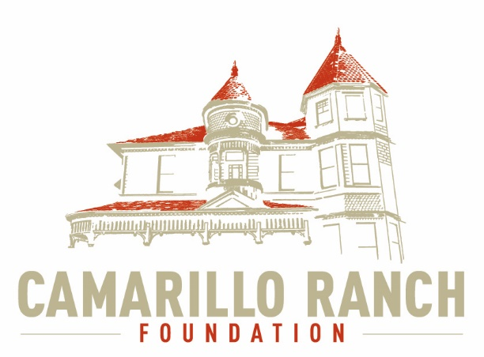 Camarillo Ranch Foundation
Board of Directors Meeting Minutes
February 3, 2021 – 5:30 pm
Camarillo Ranch – Zoom Meeting
201 Camarillo Ranch Road
Camarillo, CA. 93012

279th Meeting
“Preservation, Education, Restoration”

- Call to Order – David Schlangen called meeting to order at 5:34 PM.
Present: Betty Addieg, Christopher Valenzuela, David Schlangen, Helen Faul, Kathy Taylor, Mary Goldberg, Matt Kohagen, Mike Morgan, Theresa Marvel and Sheryl Gonzalez
Absent: Ana Blattel
Guest: Roman Kisz
- Minutes – Minutes of meeting held January 6, 2021 were unanimously approved as corrected.
- Next Meeting – March 3,2021
- Public Comments/Board Comments:
  - Public Comments regarding items not on the agenda
    - No public comments
    - No Docent Representative comments
  - Board/City Council Member Comments
    - David Schlangen stated he met with Jennifer Berry about helping with Grant writing.
    - Chris Valenzuela and David are meeting with Tammy Throckmorton, an Event Planner, for possible help with planning future events at the House.
- Unfinished Business – N/A
- New business -
  - Annual Review of Edward Jones Account (Roman Kisz)
Roman Kisz is now in charge of the account. This account is an endowment account. The hope is to not take any money out and to run the Camarillo Ranch House on Fundraisers and/or Grants. Roman will be working closely with Helen Faul and David in an advisory position. A monthly statement will be provided. The account is growing in the right direction.
  - Action to Review/Approve 2021 Board of Directors Meeting Calendar
Chris Valenzuela made a motion to approve the Boards of Directors Meeting Calendar for 2021. Mike Morgan seconded the motion. It was unanimously approved.
  - Action to Review/Approve 2021 Nomination application Timeline/Form
Gerry Olsen, Helen Faul, and Matt Kohagen updated the Nomination Form. There are presently 11 members on the CRF Board. Four seats are available. Announcement of openings will be posted in March and deadline for filing application is April 30, 2021. After reviewing the new document Matt Kohagen made a motion to approve the updated version, Helen Faul seconded the motion. The motion was unanimously approved. Kathy Taylor, Matt Kohagen, and Helen Faul will be on the Nomination Task Force.
  - Action to Review/Approve adding Friday stories to CRF website
    - A group of Docents have been creating stories, and writing well researched articles about the Camarillo family and the history of Camarillo. These stories and articles are being sent out by email to the docents and other interested parties. Martina Nicholson, great granddaughter of Adolfo Camarillo, has sent a donation to help expand the distribution of these stories by adding them to the CRF Website. David spoke to Chris and Mary about doing this. There is no problem to add these stories/articles. Board Members will be able to review the articles/stories before they are put on the Website. The suggestion was made to put these stories/articles under a legacy or history tab. The Social Media Committee will be in charge.
    - The donation from Martina Nicholson is a restricted funds donation and can’t be accepted without the approval of the CRF Board. The CRF first needed to approve adding the Friday stories to the Website. Mike Morgan made a motion to approve adding the Friday Stories to the CF website and Mary Goldberg seconded the motion. The motion was unanimously approved.
  - Continue brainstorming session on possible events for 2021 at Ranch property and begin prioritizing them. Mike Morgan and Matt Kohagen will be meeting to prioritize the suggestions. Hopefully the Ranch may begin having events this summer. Ideas brainstormed from past meeting on January 6, 2021were:
      - Carnival rides in conjunction with Throw Back Thursdays
      - Battle of the Bands
      - Gaming night
      - Casino nights
      - Movie nights
      - Bingo
      - Bunco
      - Local non-profits to provide food at different events (Lions Club, Optimist, etc.)
      - Flag day with Marching Bands
      - Non-profit day (tie in to Food Trucks)
      - Car show
      - Chili Bake-Off
Added at this meeting
      - Community Yard Sale
      - Standing events
        - Santa Night
        - Adolfo birthday
      - 50/50 raffle
      - Theresa Marvel also sent some other ideas to the Fund Raising Committee
  - Committee Reports
- Executive /Finance Committee
Helen Faul reviewed the Balance Sheet. The CRF was able to pay the expenses this month. The Internet and telephone are bundled. David Schlangen will research the provider to see if the CRF is getting a good deal.
- Education and Legacy Committee
The committee will be meeting Tuesday, February 9, 2021 at 10:00 on Zoom. This will be a one-item agenda, to discuss the Virtual Tour of the Camarillo Ranch House. Troy Wagner will be invited to attend.
- Social Media Task force
  - Chris Valenzuela and Mary Goldberg asked the members of the Board to review the Website for any changes updates, or concerns they may have. They would like to add donors’ names unless the donors object to their names being posted.
  - Chris and Mary hope to get Facebook and Instragram updated to begin focusing on posting weekly.
- Fund Development Committee
  - Matt Kohagen and Matt Morgan will set up a meeting at the end of the month to begin prioritizing events from the CRF brainstorming sessions.
- Closed Session – Yolanda Salvas and QuickBooks discussion.
Both items in closed session were unanimously approved.
- Adjournment – David Schlangen adjourned the meeting at 7:27 in Memory of Tom Blattel

Future Topics
- Action by the CRF Board on events in 2021
- City/Command Performance/CRF Calendar

CRF Subcommittee Meetings – The Foundations subcommittees meet monthly or as indicated below. All meetings are currently held virtually.

Docent Executive Committee First Monday 9:00 AM
Executive/Finance Committee Third Tuesday 5:30 PM
Social Media Task Force Second Thursday 5:00 PM
Education and Legacy Committee Second Tuesday 10:00 AM
Fund Development Committee No date at this time

_________________________________________Sheryl Gonzalez
CRF Board Minutes Feb. 3, 2021 (Feb.22.21)

Distribution:
Camarillo Ranch Foundation Board Members
City Clerk, City of Camarillo

Staff reports and other disclosable public records related to open session agenda items are available for review during regular business hours, Monday-Friday, 8:00 a.m. to 5:00 p.m., at the Camarillo Ranch Office located at 201 Camarillo Ranch Road, Camarillo, CA 93012. If you have any questions, please contact the Ranch Office at (805) 389-8182.

Americans with Disabilities Act Compliance Statement
In compliance with the Americans with Disabilities Act, if you need special assistance to participate in this meeting, please contact the Camarillo Ranch Office at (805) 389-8182 at least 48 hours prior to the meeting to enable us to make reasonable accommodations to ensure access to this meeting. (28 CFR 35.102-35.104, ADA Title III)

